Read the text and complete the identity card:

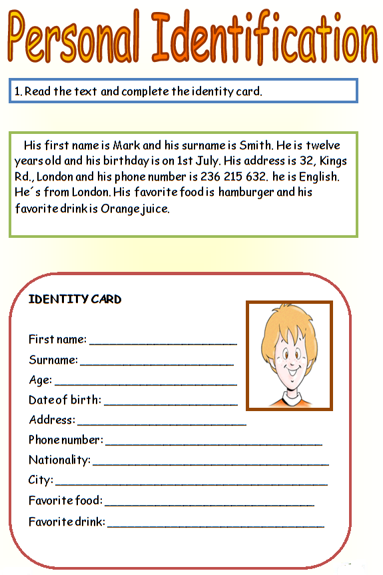

Watch this video, and then complete next chart with the characteristics of each season:

Season | 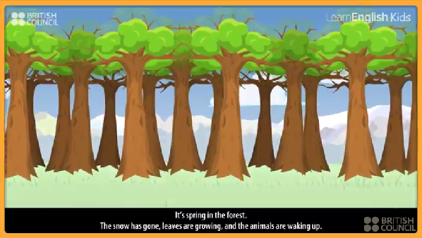  Characteristics
Summer | - Bruno is…
Winter | - Bruno is…
Fall | - Bruno is….
Spring | - Leaves are growing …..  - Bruno is…..

Complete next chart with the actions you do in each part of your house, specify the time.

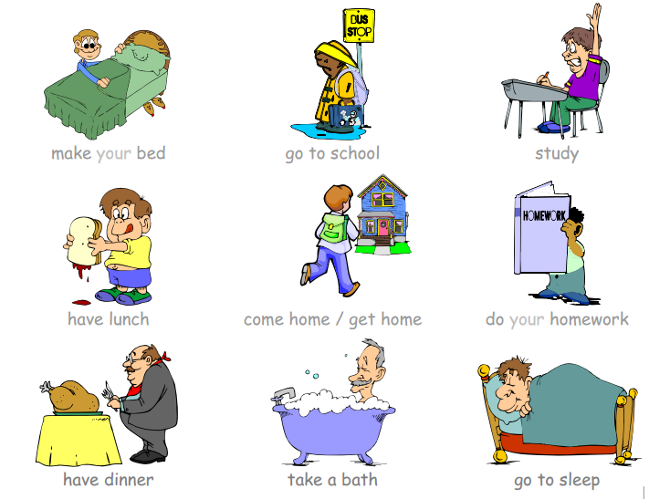
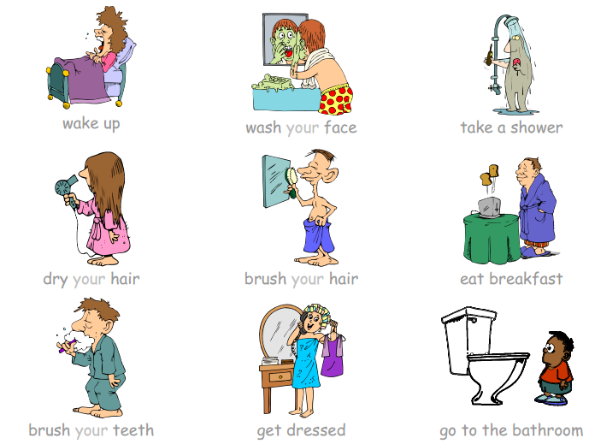

Part of the house | Action | Time (hour)
Kitchen | Eat breakfast | 6:30 am
Bedroom
Bathroom
Living room
Dining room
Study

Watch this video, the images, listen to the actions, then put the options in the correct order according to the same order on the video, and finally look for the meaning in Spanish.
http://www.youtube.com/watch?v=sIe8lwgDcVY

 | Correct order | Spanish | Options
1 |  |  | Make your bed
2 |  |  | Go to school
3 |  |  | Go home
4 |  |  | Wash your face
5 |  |  | Brush your teeth
6 |  |  | Take a bath
7 |  |  | Take a shower
8 |  |  | Get dressed
9 |  |  | Study
10 |  |  | Do your homework
11 |  |  | Wake up
12 |  |  | Go to bed
13 |  |  | Dry your hair
14 |  |  | Eat dinner
15 |  |  | Eat lunch
16 |  |  | Eat breakfast
17 |  |  | Go to the bathroom
18 |  |  | Brush your hair

RESOURCES

Fable: where’s Bruno?
http://learnenglishkids.britishcouncil.org/es/short-stories/the-lazy-bear

Memory game: the weather
http://www.anglomaniacy.pl/weatherMatching.htm

